**GRAPH THEORY**

**What is Graph?**

Graph is a collection of objects which may or may not be connected to each other. A good example of a graph can be a network of computers.

Graph Theory can be used to represent many real world problems.

**Seven Bridges of Konigsberg**

There are seven bridges alongside the riverbanks and two islands as shown below we need to find a path such that we travel each bridge exactly once.

There is no solution to this problem!

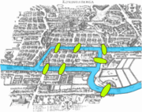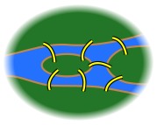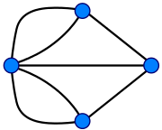

**Definition:**

A graph is a collection of nodes and edges denoted as G= (V,E) here V represents nodes(points) and E represents edges(links).

**Types of Graphs**:

Undirected: We can navigate in both directions on an edge.

Directed: We can navigate in a fixed direction on an edge.

Weighted: A weight (value) is associated to the edge.

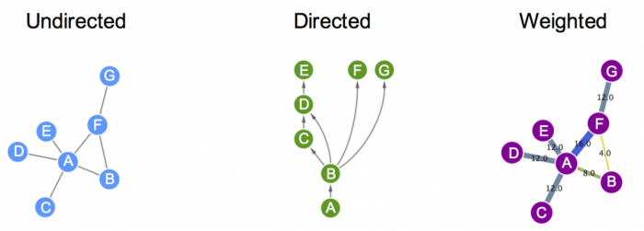

**Graph Terminologies:**

Adjacent nodes: Two nodes are adjacent if they are connected via an edge.

Loop: An edge whose both ends are connected to the same point.

Degree: Number of edges connected to the given point.

Path: Traversal of points of graph such that no point is crossed twice.

Walk: A path in which we can visit points multiple times.

Cycle: A closed path.

**Graph Representation:**

* **Adjacency Matrix:** Graph is represented in form of a matrix with the rows and columns representing nodes non zero values represent edges

Undirected Graph

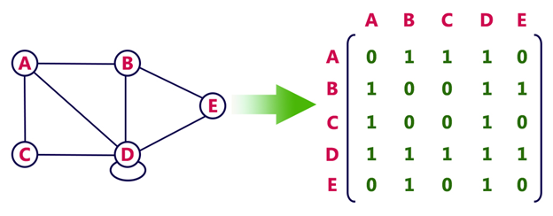

Directed Graph

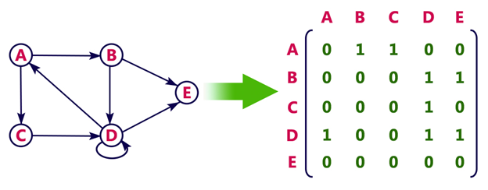

Undirected Weighted Graph

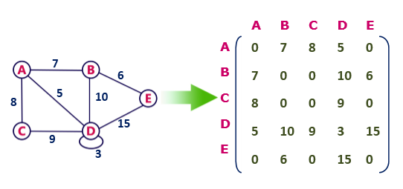

* **Incidence Matrix:** Graph is represented in the form of a matrix with rows as nodes and columns as edges.

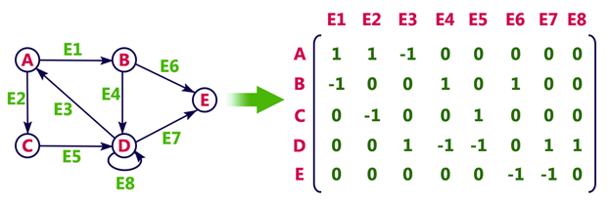

* **Adjacency List:** Graph is represented in the form of an array which points to a linked list.

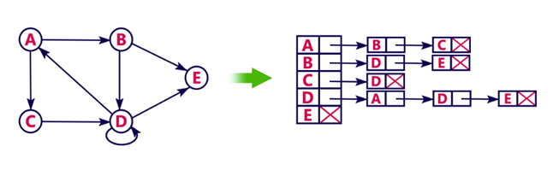

**Applications:**

**Database Design:** Graph database utilizes a representation of a graph with nodes, edges, and properties to represent and store data. Graph databases are often faster for associative data sets that map more directly to the structure of object-oriented applications.

**Data Structure:** The logical or mathematical model of a specific organization of data is called a “Data Structure”. The selection of data model depends upon two deliberations:

1. It must be rich enough in structure to represent the actual relationship of data in the real world.

2. The structure should be an adequate that one can effectively process data when necessary.

These two considerations are fulfilled by the graph theoretical concepts. The algorithms of graph theory is involved in are

a) Searching graphs by utilizing Breadth-first Search and Depth-first search

b) Shortest Path Algorithms

c) Minimum spanning tree algorithm

d) Detecting cycles in graphs

**Computer Hardware:** Graph theory concepts are utilized in computer hardware to model the limitations of the physical layer.

1. Graph colouring is utilized to allocate a register

2. Adjacency matrix is used for representing of sequence of instructions

3. Processing parallel instructions

4. Allocation of process scheduling

**Operating System:** Many practical problems can be solved with the help of graph data structures in the field of an operating system such as job scheduling, resource allocation problems. For example, graph colouring concept can be applied in job scheduling problems of CPU, jobs are assumed as nodes of the graph and edge between two jobs that cannot be executed simultaneously and there will be one to one relationship between the feasible scheduling of graphs.

**Image processing:** Image analysis is the methodology by which information from images is extracted. The graph-based methods for image processing are segmentation, filtering, classification, and clustering. The applications of the graph in image processing are: to find edge boundaries using graph search algorithms in segmentation.

Other Applications are Data Mining, Web Designing, Network Systems and security, Artificial Intelligence etc.